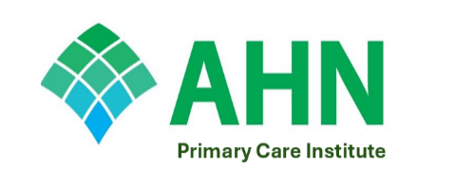
Enhance your expertise in dermatological care and confidently identify and manage common skin conditions in your practice.
AHN Primary Care Institute presents:
Empowering Primary Care: A Full-Day Workshop on Dermatology Procedures and Condition Identification

Date: Thursday, April 30, 2026
Time: 8:00 AM - 4:00 PM
Location: Regional Learning Alliance, Cranberry, PA
Who Should Attend? Primary Care Physicians, Advanced Practice Providers (APPs), and Residents interested in expanding their knowledge and skills in dermatology.
What You Will Learn: This comprehensive workshop is designed to equip primary care providers with practical skills and up-to-date knowledge to better serve their patients' dermatological needs. Topics will include:
Presentations on Key Dermatology Topics:
- Wound Care Management in Primary Care
- Dermatological Conditions in Skin of Color
- Early Detection and Management of Skin Cancer
Hands-on Skills Stations:
- Punch and Shave Biopsy Techniques
- Excisional Biopsy Fundamentals
- Effective Use of the Dermatoscope
This conference is only open to Primary Care Providers and will be capped at 100 attendees

Registration Fees:
- Primary Care Physicians: $100
- Primary Care APPs: $75
- Primary Care Residents: $50
- Scan the QR code to register:

Don't miss this opportunity to advance your primary care practice! CME credits will apply
For Questions, Please Contact: Beth.Strauss@ahn.org or email primarycareinstitute@ahn.org
This is an in-person seminar only. No virtual option will be offered.
Allegheny General Hospital is accredited by the Accreditation Council for Continuing Medical Education to provide continuing medical education for physicians.
Allegheny General Hospital designates this live activity for a maximum of 6.0 AMA PRA Category 1 CreditsTM

