Powered by Vital Talk-Mastering Tough Conversations Training
Location: Virtual-Teams Video Call
Date/Time: Wed. July 30th 8am-4:30pm
Greetings,
You have been identified as a candidate for the Powered by Vital Talk communication skills course- Mastering Tough Conversations. Please save the date and register for the sessions to secure your spot.
About Powered by Vital Talk: Learn to communicate effectively and compassionately with patients living with serious illness. Explore best-practice communication methodologies and tools, as well as our rich community of support to better serve the needs of patients with serious illness and their families. Our AHN/Highmark faculty trainers have been certified by Vital Talk to facilitate learning sessions. This session consists of a mix of didactic learning sessions as well as live role play with standardized patient actors.
Prerequisites:
- Registration requires the creation of a CME account at AHN- If you do not already have an account, please create your account at: https://cme.ahn.org/login?destination=node/47114
- Register for the course at: https://cme.ahn.org/content/powered-vital-talk-virtual-july-30th-2025-justin-engleka-crnp-dr-linsey-odonnell-do-maria#group-tabs-node-course-default1
Use required passcode: VITAL72025 (please do not share this code. It is intended for this audience only).

3.Completion of the Center to Advance Palliative Care (CAPC) Communication Skills Bundle
Visit www.capc.org to create your user account. Register under your hospital or employer.
Search- Clinical Training – Click “Take online clinical training courses.”
Complete all 5 Communication Skills courses for Serious Illness Conversations
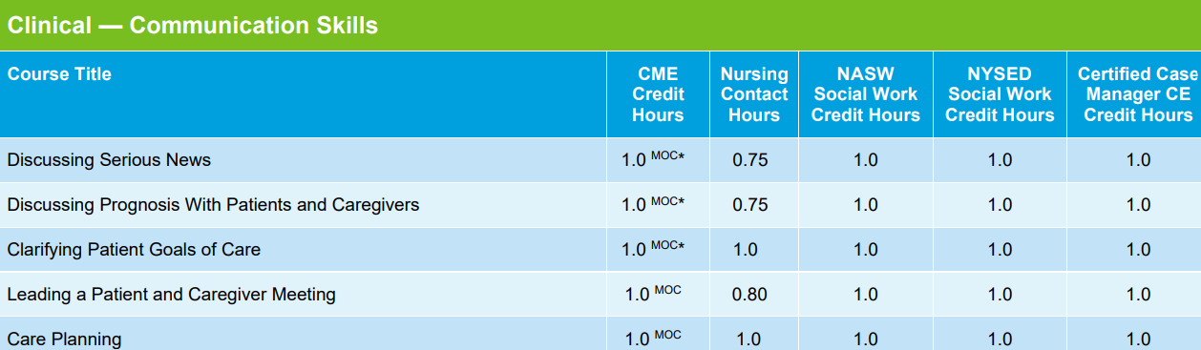
3. Click hyperlinks below (first part of the link) to access and watch prerequisite videos prior to the day of the course:
- Video link: VR1 REMAP - Overview | Rise 360 (articulate.com)
- Video link: Class 1: RE of REMAP - Overview | Rise 360 (articulate.com)
- Video link: Class 2: MAP of REMAP - Overview | Rise 360 (articulate.com)
Questions and cancelations: Contact Justin Engleka- Senior Program Manager-Highmark Health at justin.engleka@highmarkhealth.org

Continuing Medical Education Statement:
Accreditation
Allegheny General Hospital is accredited by the Accreditation Council for Continuing Medical Education to provide continuing medical education for physicians.
Allegheny General Hospital designates this live activity for a maximum of 6.5 AMA PRA Category 1 CreditTM. Physicians should claim only the credit commensurate with the extent of their participation in the activity.
American Nurses Credentialing Center (ANCC) accepts AMA PRA Category 1 Credits™ from organizations accredited by the ACCME.
American Academy of Nurse Practitioners (AANP) accepts AMA PRA Category 1 Credits™ from organizations accredited by the ACCME.
The National Commission on Certification of Physician Assistants (NCCPA) states that the AMA PRA Category 1 Credits™ are acceptable for continuing medical education requirements for recertification.
Allegheny General Hospital has approved this activity for 6.50 contact hours for non-physicians
CE for Psychologists
Allegheny General Hospital is approved by the American Psychological Association to offer continuing education for psychologists. Allegheny Health Network maintains responsibility for the program and its content.”
CE for Social Workers
Allegheny Network is an approved provider for APA credits for Psychologists. This conference is approved for 8.00 APA credits. Social Workers may claim credits for attending educational courses and programs delivered by pre-approved providers, such as the American Psychological Association (refer to CE for Psychologists above). For verification, please refer to Continuing Education Regulations§47.36 #(6)(ix)found atwww.dos.state.pa.us/social.www.dos.state.pa.us/social.
Disclosure Statement
In accordance with the Accreditation Council for Continuing Medical Education (ACCME) and the policy of Allegheny General Hospital, presenters must disclose all relevant ﬁnancial relationships, which in the context of their presentation(s), could be perceived as a real or apparent conﬂict of interest, (e.g., ownership of stock, honorarium, or consulting fees). Any identiﬁable conﬂicts will be resolved prior to the activity. Any such relationships will be disclosed to the learner prior to the presentation(s).
The presenters for Powered by Vital Talk have nothing to disclose.

