Series: Wellness Grand Rounds
Special thanks to Dean Charles Cairns, MD, and the Drexel University College of Medicine Office of Faculty for their support of this Grand Rounds through the Wellness, Vitality and Engagement (WAVE) Grant program

Title: Organizational Approaches to Foster Clinician Well-being

Date: February 27th, 2025
Time: 12:00-1:00 pm
Location: via Zoom (Click HERE for link)

National Speaker: Tait Shanafelt, MD, Director of the Stanford WellMD Center, Chief Wellness Officer for Stanford Medicine
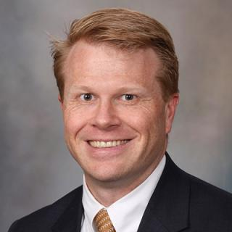
Dr. Tait Shanafelt is the chief wellness officer, associate dean, and Jeanie and Stewart Richie Professor of Medicine at Stanford University. His pioneering studies over the last 25 years are credited with helping launch the entire field of organizational efforts to promote clinician well-being. He has published over 500 peer reviewed manuscript and has served as a keynote speaker to the ACGME, AAMC, AMA and ABIM on the topic of clinician well-being. His studies in this area have also been cited by CNN, USA Today, , and The New York Times. In 2018, he was named by TIME Magazine as one of the 50 most influential people in healthcare.
Clinically, Shanafelt’s focus is caring for patients with chronic lymphocytic leukemia (CLL). He is an R01 funded investigator and previously served a seven-year term as a member of the National Cancer Institute (NCI) Leukemia Steering Committee.

Accreditation: Allegheny General Hospital is accredited by the Accredited Council for Continuing Medical Education to provide continuing medical education for physicians.
Allegheny General Hospital designates this live activity for a maximum of 1.0 AMA PRA Category 1 Credits ™.
Speaker: Dr. Shanafelt has nothing to disclose.
Course Director: Dr. Thomas Campbell has nothing to disclose.

