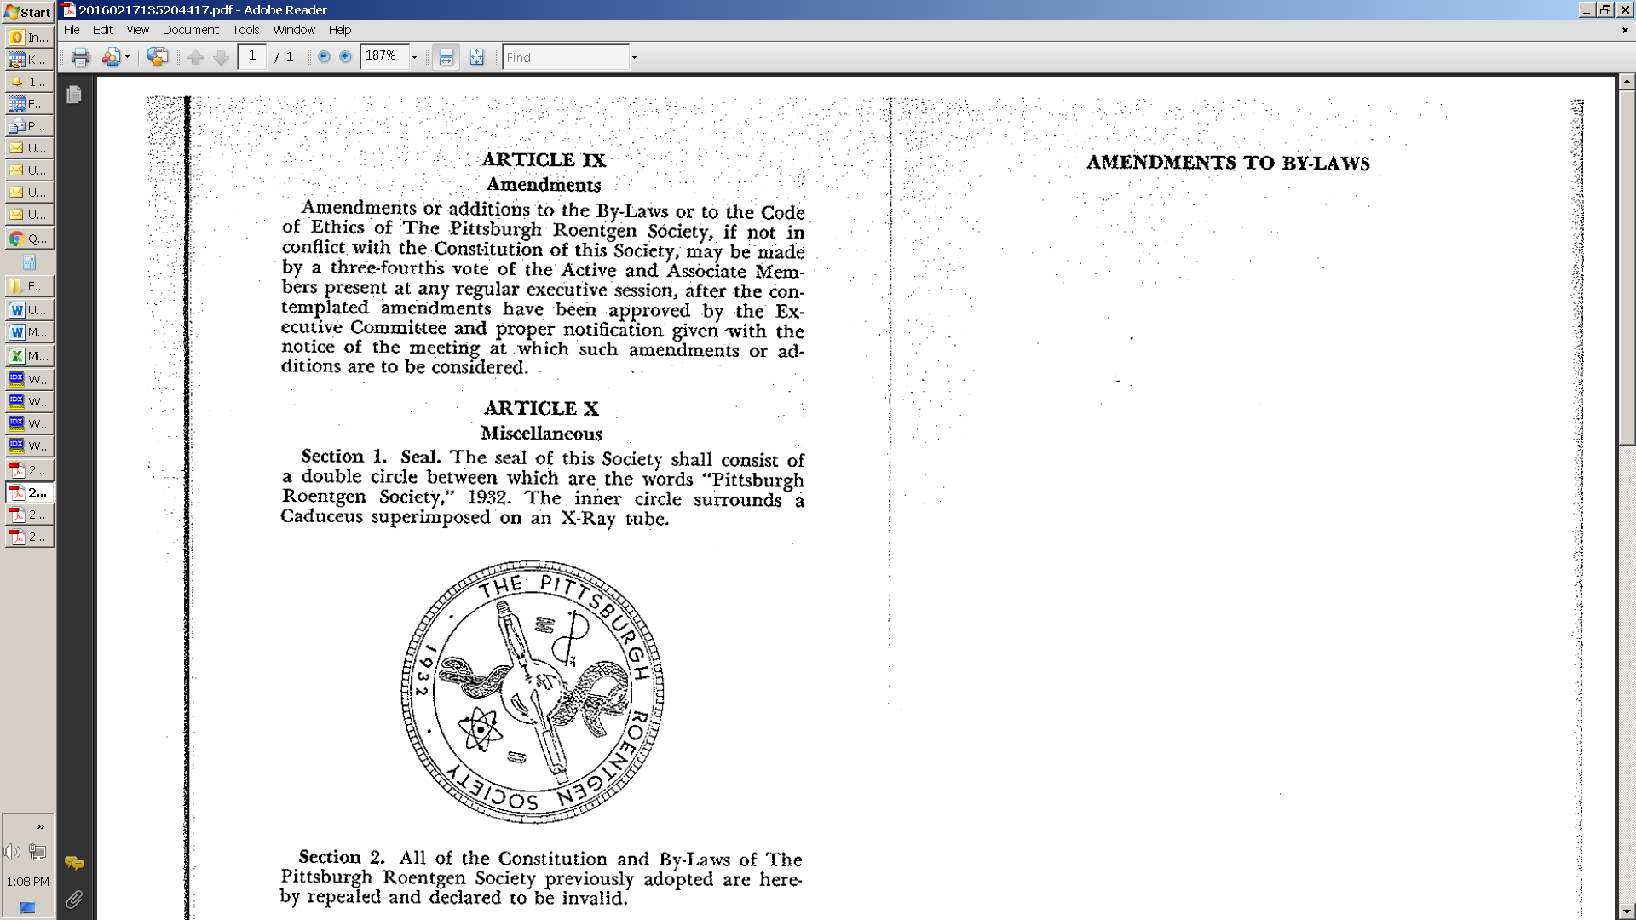

# The Pittsburgh Roentgen Society

**2024 FALL MEETING**

September 19, 2024

LeMont Restaurant

1114 Grandview Avenue

Pittsburgh, PA 15211

**Target Audience**

Approximately 80 radiologists from the greater Pittsburgh and surrounding regions

**Agenda**

5:30 pm - 6:00 pm – Meet and Greet with Hors d’oeuvres

6:00 pm - 7:00 pm – Azza Elgendy, MD – Resident Quiz and Answers

7:00 pm - 8:30 pm – Paul Chang, MD – Maturing Beyond Adolescence to Enable the Return of the Doctor’s Doctor

8:30 pm - 9:00 pm – Questions/Discussion

9:00 pm - Adjournment

**Guest Speakers:**

**Paul Chang, MD, FACR, FSIIM**

Professor and Vice Chair, Radiology Informatics, Department of Radiology, University of Chicago School of Medicine

**Azza Elgendy, MD**

Assistant Professor of Radiology , Department of Radiology, University of Pittsburgh

This activity has been planned and implemented in accordance with the essential areas and policies of the Accreditation Council for Continuing Medical Education (ACCME) through joint providership of Allegheny General Hospital and Pittsburgh Roentgen Society.   Allegheny General Hospital is accredited by the Accreditation Council for Continuing Medical Education to provide continuing medical education for physicians.

Allegheny General Hospital designates this live activity for a maximum of 3.0. A*MA PRA Category 1 CreditsTM.* Physicians should claim only the credit commensurate with the extent of their participation in the activity.

Disclosure Statement

In accordance with the Accreditation Council for Continuing Medical Education (ACCME) and the policy of Allegheny General Hospital, presenters must disclose all relevant ﬁnancial relationships, which in the context of their presentation(s), could be perceived as a real or apparent conﬂict of interest, (e.g., ownership of stock, honorarium, or consulting fees).  Any identiﬁable conﬂicts will be resolved prior to the activity. Any such relationships will be disclosed to the learner prior to the presentation(s).