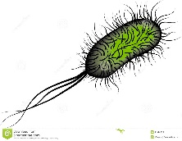
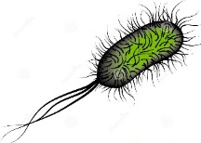

The 2023 John L. Blair Memorial Lecture

“Antibiotic Stewardship
in the Outpatient Arena”

presented by
Nathan R. Shively, MD
Medical Director, Antimicrobial Stewardship Program, Allegheny Valley Hospital
Division of Infectious Disease
Allegheny Health Network
Pittsburgh, PA

This lecture is designed to increase our knowledge of the most common infections seen in the outpatient setting and the currently recommended treatments. If antibiotics are indicated…using the right antibiotic at the right time, at the right dosage for the right length of time. This issue is crucial to slow the increasing resistance to antibiotic effectiveness, being seen both locally & internationally.

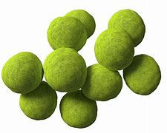
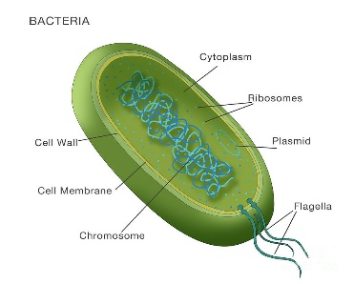
Thursday, May 4th, 2023
7:00 p.m.
Conewango Club
Warren

This activity has been planned and implemented in accordance with the essential areas and policies of the Accreditation Council for Continuing Medical Education (ACCME) through joint providership of Allegheny General Hospital and Warren General Hospital. Allegheny General Hospital is accredited by the Accreditation Council for Continuing Medical Education to provide continuing medical education for physicians.
Allegheny General Hospital designates this live activity for a maximum of
1.0. AMA PRA Category 1 CreditTM.
Physicians should claim only the credit commensurate with the extent of their participation in the activity.. In accordance with the Accreditation Council for Continuing Medical Education (ACCME) and the policy of Allegheny General Hospital, presenters must disclose all relevant ﬁnancial relationships, which in the context of their presentation(s), could be perceived as a real or apparent conﬂict of interest, (e.g., ownership of stock, honorarium, or consulting fees). Any identiﬁable conﬂicts will be resolved prior to the activity. Any such relationships will be disclosed to the learner prior to the presentation(s).

The John L. Blair Lecture Series is made possible by the generous endowment
for medical education given by Mrs. Maude Blair to Warren General Hospital in 1970 to honor her husband.

