TITLE OF THE COURSE
Description of the course
Description of the course
Description of the course

Dates | Dates | Dates | Dates | Dates | Dates
Time | Time | Time | Time | Time | Time
CODE | CODE | CODE | CODE | CODE | CODE
*delete the columns you don’t need (and this note)
HOW DO I RECEIVE CREDIT?
Complete your profile on the AHN CME site
From AHN Central > Education and Resources > Continuing Medical Education, click the AHN/Highmark User Login or My Account link in the header.
Log in using your AHN email and password and complete the Account, Profile, and Mobile sections.
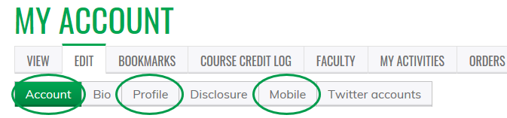

Text code to 412-301-9919
Note: if you text before your mobile number is linked to your CME Account, you will not receive credit.

